6.4 Synopsis

**MIT School of Engineering**

**Department of Computer Science and Engineering**

**Mini Project Synopsis**

**Group ID: 4**

**Project Title: Extraction of text from image + text to speech conversion**

**Group Members:**

| **Enrollment**  **Number** | **Roll No.** | **Name of**  **student** | **Email Id** | **Contact**  **Number** |
| --- | --- | --- | --- | --- |
| MITU21BTCS0082 | 2213500 | Aniket Ankush More | animore14@gmail.com | 9892467410 |
| MITU21BTCS0104 | 2213501 | Anushka Girish | anushka.girish2020@gmail.com | 9146243378 |
| MITU21BTCS0344 | 2213514 | Nandini Sahu | nandinisahu407@gmail.com | 8669089763 |
| MITU21BTCS0613 | 2213483 | Siddhi Shewale | siddhi.shewale12345@gmail.com | 9604884473 |

**Problem Statement:**

**Convert the given specific image into text . The text thus received is converted into speech.**

**Abstract:**

**Text recognition in images is an active research area which attempts to develop a computer application with the ability to read the text from image automatically. This project has been developed for university students.It helps students to convert images into simple text. And even the extracted text can be converted into simple english speech.The challenges involved are font characteristics of the characters in paper documents and quality of the images. Due to these challenges, the computer is unable to recognize the characters while reading them. Thus, there is a need of character recognition mechanisms to perform document image analysis which transforms documents in paper format to electronic format.**

**Attempts have been made to develop vocally interactive computers to realise voice/speech synthesis. Obviously such an interface would yield great benefits. In this case, a computer can synthesize text and give out a speech. Text-To-Speech Synthesis is a Technology that provides a means of converting written text from a descriptive form to a spoken language that is easily understandable by the end user (Basically in English Language).**

**One simple way to store information from these paper documents in to computer system is to first scan.**

**Literature Survey: Detail survey done**

**Proposed System (Block Diagram):**

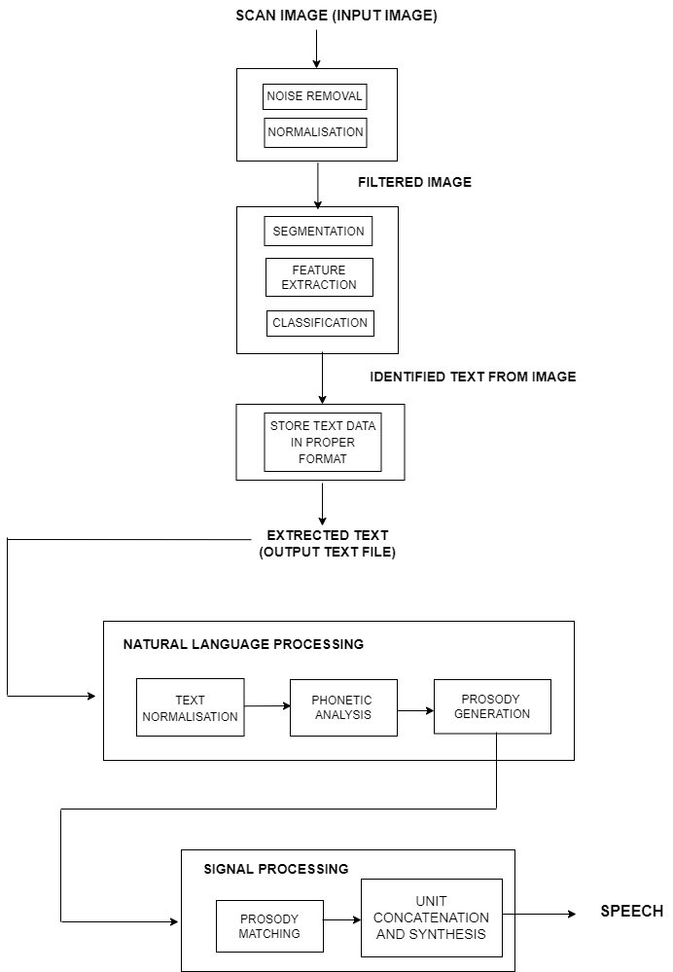

**Conclusion:**

**Therefore we are able to learn many new functions and libraries in python and to implement them. This project would help many students to overcome language issues, save time and energy.**

**Synthesizing text is a high technology advancement and artificial formation of speech given a text to be spoken.**

**References:**

**Year-2015: A Technical Review On Text Recognition From Image -by Pratik Madhukar Manwatkar, Department of computer technology,YCCE,Nagpur(M.S)**

**-Dr kavita R.Singh, Department of computer technology,YCCE,Nagpur(M.S)**

**Annexure:**

**Annexure I: Form A-Title Approval (for offline mode)**

**Annexure II: Form B-Market and financial feasibility (verify from guide) Annexure III: Literature survey paper or links**